

**THIRD TERM EXAMINATION - 2020**

**GRADE 11 – History II**

**03 Hours**

**Part I**

01. Mark the following places on a given Sri Lankan map and a given world map.  
  
(A ). Minihagalkanda , Lankapatuna , Kala wewa , Yodha wewa , Minipe anicut , Pallawawanka ,

Deeghawapi , Pahiyangala , Kirindi Oya , Nallur , Devinuwara , Kalpitiya **(12)**  
  
(B). Japan , Malaya Peninsula , Black Sea , Venice , Persian Gulf , Constantinople **(06)**

(C). Answer the following questions.

1. First ruler of the Nayakkar dynasty -  
2. The prime minister who built the fortress of Kotte -  
3. The first British envoy who visited Sri Lanka -  
4. The primary level halls / houses built for bhikkhus during the earliest stage -

**(04)**

(D). Answer the questions based on the pictures given below.

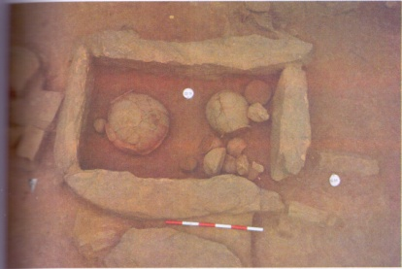

01. 1. What is the name used to introduce the burial ground

shown in the picture ?  
2. Where is the burial ground located?  
3. To which historical era does this burial ground belong to?  
4. Name another place where you can find the same type of

a burial ground.

**(04)**

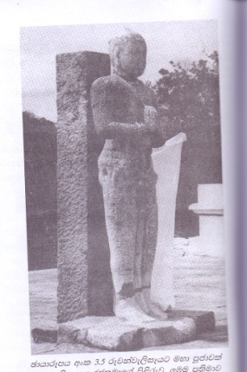

02. 1. Who is shown in the picture?  
2. What is the place that you can see this statue?  
3. What is the service rendered to the place where it is located by this

ruler who is shown by the statue?  
4. The ruler shown in the picture sent a delegation to a foreign state

during his reign. Name the state.

**(04)**

**Part II**

02. (i). Write 03 environmental zones where the Pre - historic people lived.

(ii). Name the eras that the following features could be seen.

1. Parts of finely finished clay pots

2. Establishment of Vaapigaama

3. Using micro stone tools

4. Urn burials

(iii). Describe the differences of the Pre historic era and the Proto historic era by citing 02

factors.

(iv). Describe the advancement of the technology of the Proto historic era by explaining

the following topics.

A - Clay tub burials

B - Establishment of permanent settlements

C - Making earthenware  
  
03. (i). Name the sources which helps to find the following facts,

A - Gamikas were appointed from Gahapathis

B - A poor villager had borrowed a bag of paddy from a Gamika

C - Provincial rulers were also known as Pochani Raja

(ii). Describe the following taxes ;

A – Dakapathi

B – Matheramajibaka

C – Bojakapathi

D - Kethi ada

(iii). Describe 02 main responsibilities of kings towards the well being of the general public during the ancient period by citing atleast 02 examples.

(iv). Name 02 important kings who rendered a great political service towards the evolution of power in the island and describe their services by citing atleast 02 examples.

(04) (i) What are the factors that have been mentioned in the following inscriptions ?  
  
A - Kondawattawan  
B - Wewelketiya  
C - Wessagiriya  
  
Laws related to the criminal offences , Laws imposed on internal markets , Laws related to environmental conservation , Features of a tank

(ii) Name the places where the evidences were found related to the following facts .  
  
D - Air is essential for the process of burning  
E - Metal scissors used for surgeries  
F - Leaching iron by using natural wind power  
G - Lightening conductor

(iii) Write short answers to the following questions .  
  
H - The king who laid the foundation to construct large scale tanks  
I - An officer related to the construction of canals  
J - The canal that diverts water to four large scale tanks  
K - The tank bund which is built with a several soil layers to ensure it's strength  
L - The inscription that mentions the word ' Mohol naga '

(iv) Large scale tanks were not consructed during the second urbanization. What were the main reasons that influenced this situation? Describe by citing atleast 03 examples.

(05) (i) Name the kingdoms of the following kings  
  
A - King Parakramabahu II  
B - King Buwanekabahu IV  
C - King Parakramabahu VI

(ii) Mention 02 kingdoms of the First Urbanization and 02 kingdoms of the Second Urbanization.

(iii) Describe the political services of two important rulers of the Kingdom of Kandy.

(iv) Describe the two aspects of Rajakariya System.

(06) (i) Name 03 British representatives who conducted mutual relations with the kingdom of Kandy.

(ii) Write two taxes for each, that influenced the following uprisings in,   
  
A - 1797 AD  
B - 1848 AD

(iii) British invasion of 1803 AD was unsuccessful but their invasion of 1815 AD was successful. Describe 01 reason for failure of 1803 AD invasion for the success of 1815 A.D invasion.

(iv) Describe the two main reasons that influenced the second liberation struggle of 1848 AD.

(07) (i) What were the constitutional reforms that the following features could be seen in ?  
  
A - Introduction of the limited franchise  
B - Unofficials became the majority of the constitutional council  
C - Dual chamber legislature was established

(ii) Write 02 features each of the First Republican Constitution of 1972 and the Second Republican Constitution of 1978.

(iii) Describe 02 reforms of the Colebrooke - Cameron Commission of 1833.

(iv) Establishment of farming settlements and the Mahaweli development project directly influenced the development of rural economy. Describe the positive influence of these two projects under 03 facts.

**Part III**

08. (i) Write 03 reasons that influenced the emergence of Renaissance.

(ii) Write 04 sectors that developed under the influence of Renaissance.

(iii) Describe 01 political factor and 01 economic factor that influenced Renaissance.

(iv) Renaissance was the initiative step of creating a global village. Describe in your own words.

09. (i) Mention the liberation struggles related to the following slogans.  
  
A – Peace , Lands and Bread  
B - No member , no tax  
C - Freedom , equality , brotherhood

(ii) Write 02 reasons that influenced the establishment of settlements by the Europeans in America.

(iii) A - Write two taxes that influenced the emergence of the French Revolution.  
  
B - Name the three philosophers who aroused the ideas about freedom among people.

(iv) Historical revolutions had gifted many things to the world. Describe this statement with 03 examples.